A Parent’s Guide to *Math Accelerated*

Students can access the complete student edition of *Math Accelerated* from a home computer in order to:

* Complete homework
* Review vocabulary
* Locate extra practice
* Watch tutorials on that day’s lesson
* Self-assess
* Utilize virtual manipulates of mathematical concepts

1. 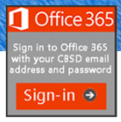 Students will login to Office 365

Use *cbsd.org/365* to find the sign-in page

1. Click and use their school username and password.
2. Go to *myapps.microsoft.com* and bookmark or pin this tab for later.
3. Click on the ConnectED icon and then Glencoe Math Accelerated.

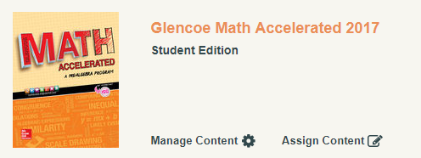

1. In the Home page students choose the chapter and lesson

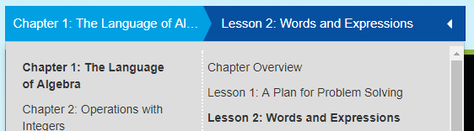

1. To access the textbook, click the eBook icon.

1. Students will find vocabulary, tutorials, manipulatives, and a self-check quiz on the home page as well.



1. To locate extra skills practice worksheets, problem solving tasks, and homework practice

Click the menu button and then Resources. 